Healthwatch Doncaster
Board Information Pack
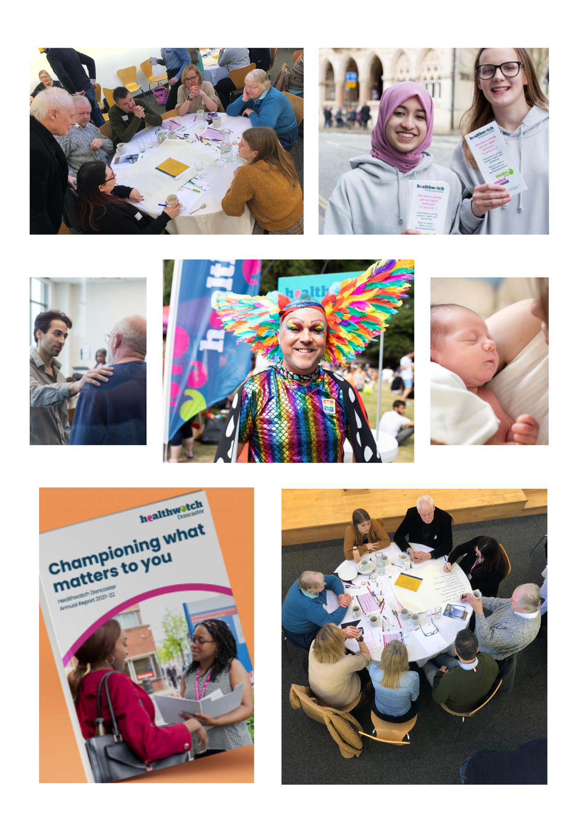

Table of contents Page No

- What is Healthwatch?
  - Why do we exist? 3
  - Healthwatch England role
  - Local Healthwatch role

- Doncaster Healthwatch history 4

- Doncaster Place 4

- Vision 5

- Meet the team 6
  - Organisation chart

- Engagement 7

- Volunteering 7

- Responsibility of Board Members 8,9

1. What is Healthwatch
a. Why do we exist?
Healthwatch was established under the Health and Social Care Act 2012 to understand the needs, experiences and concerns of people who use health and social care services and to speak out on their behalf.
We exist on a national and local level, working towards the same goal of enabling people to have a voice about their health and social care systems.

b. Healthwatch England role
Healthwatch England are a statutory committee of the independent regulator the Care Quality Commission (CQC). The main statutory functions are to:
- Provide leadership, guidance, support and advice to local Healthwatch organisations.
- Escalate concerns about health and social care services which have been raised by local Healthwatch to CQC. CQC are required to respond to advice from the Healthwatch England Committee.
- Provide advice to the Secretary of State for Health and Social Care, NHS England and English local authorities, especially where we are of the view that the quality of services provided are not adequate. Bodies to whom advice is given are required to respond in writing. The Secretary of State for Health and Social Care is also required to consult Healthwatch England on the NHS mandate, which sets the objectives for the NHS.
c. Local Healthwatch role
Local Healthwatch are funded by and accountable to local authorities.
Their main statutory functions are to:
- Obtain the views of people about their needs and experiences of local health and social care services. Local Healthwatch make these views known to those involved in the commissioning and scrutiny of care services.
- Make reports and make recommendations about how those services could or should be improved.
- Promote and support the involvement of people in the monitoring, commission and provision of local health and social care services.
- Provide information and advice to the public about accessing health and social care services and the options available to them.
- Make the views and experiences of people known to Healthwatch England, helping us to carry out our role as national champion.
- Make recommendations to Healthwatch England to advise the CQC to carry out special reviews or investigations into areas of concern.

2. Doncaster Healthwatch History

Doncaster Healthwatch CIC was established in May 2016 as an independent Community Interest Company (CIC). The original contract for local Healthwatch services novated to Doncaster Healthwatch CIC from Carers Federation on 1 July 2016.

Doncaster Healthwatch CIC were successful in the initial tender for the provision of local Healthwatch services in Doncaster and have secured a contract from 1 August 2017 for 3 years with two 1-year extensions.

In July 2022, Doncaster Healthwatch was again successful in securing a further 3 years of funding.

3. Doncaster Place

The provision of health and social care has moved from the local authorities and Care Commissioning Groups based in Doncaster, Barnsley Rotherham and Sheffield to an Integrated Care Board that will serve the whole of South Yorkshire.

The concern about such a move is that local communities may feel that they are less connected to the services that are provided in their local areas. The idea of "Place" is to put the local areas at the forefront of considerations when deciding what and where to provide health and care services.

Doncaster's Health and Wellbeing Board (upon which Healthwatch Doncaster has a seat) guides the provision of local services in line with its agreed priorities. These priorities are local and specific to Doncaster.

The centre of Doncaster's strategy is around three themes of Starting Well infants and children), Living Well (adults) and Aging Well (older people).

4. Vision

Healthwatch Doncaster's vision is for the provision of a service for all the citizens of Doncaster that enables anyone from any part of our community to have somewhere to speak up about their opinions on the commissioning, design and provision of health and wellbeing services in the Borough and for their voice to be heard, considered and factored into decision-making.

We seek to engage with our citizens, inform them about what is happening in health and social care and how it affects their lives and influence service commissioner, designers and providers.

5. Meet the Team
Healthwatch Doncaster staff
Fran Joel Chief Operating Officer
Sandra Hodson Project Officer
Elle Smith Engagement Officer
Sian Owen Outreach and Volunteer Officer
Natalie Bowler-Smith Community Engagement Officer
Vacant Marketing, Communications & Admin Support

Healthwatch Doncaster Board
Steve Shore Chair
Andrew Bosmans
Debbie Osborne
Steve Lyons
Fran Joel

- Organisation Chart

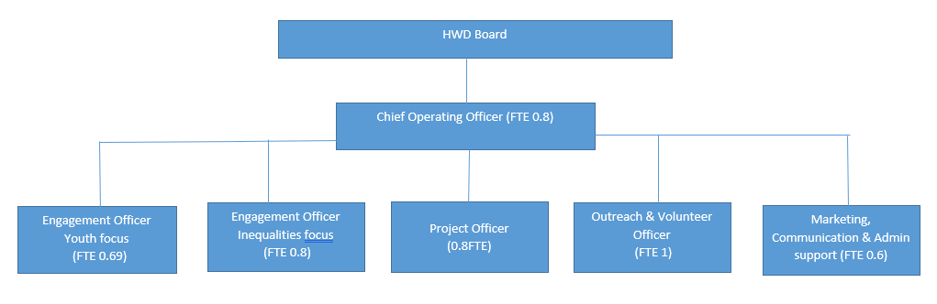

6. Engagement
Our engagement takes place with all people of the community, we want to incorporate diversity and hear the views of everyone, reaching out to as many different groups, meetings and events as possible.
Helping adults, children and young people, we influence and improve how services are designed and operate.
We use the views of people in the community to raise concerns with the people running NHS and social care services to make improvements.
We cover all types of services including:
- Care Home
- GP
- Home Care
- Mental Health
- NHS Dental
- Pharmacy
People’s experiences of the services they use can also be given anonymously.
We also share our messages across Social Media Channels, engaging with as many different audiences as possible.
- Facebook
- Twitter
- Instagram
- LinkedIn

7. Volunteering
There are plenty of opportunities to volunteer and make a difference to the community.
Our volunteers:
- Make a difference by giving people the opportunity to speak up about their health and social care
- Make new friends and become part of the Healthwatch team
- Develop new skills and confidence
- Contribute to the success of Healthwatch across Doncaster
Our volunteer offer is extremely flexible so even someone who doesn’t have much free time can still make a valuable contribution, helping local people have their say about health and social care services.
We train some of our volunteers to visit health and social care services and report on people’s experiences.
During the Covid-19 pandemic, volunteering has developed in a different way as our volunteers have adapted to staying in touch online, ensuring the voice of Doncaster is still heard and continuing to raise awareness of Healthwatch.
Our volunteers are an integral part of Healthwatch Doncaster’s journey and success.

8. Responsibilities of Board Members
Healthwatch Doncaster Board are responsible for the governance of Healthwatch Doncaster.
The Board’s key role is to direct and control the work of the organisation to:
- Determine the strategic direction and policies
- Ensure the activities of Healthwatch Doncaster reflect the diverse communities of Doncaster, not just the views of majority groups or the most high profile issues
- Establish and oversee control and risk management operations
- Ensure that Healthwatch Doncaster achieves its aims and objectives
- Oversee operational management and ensure the implementation of Board policies
The specific responsibilities and accountabilities of the Board are to:
- Ensure that the vision and values of Healthwatch Doncaster are realised and upheld
- Define the direction of the organisation’s business, service and activities
- Ensure clear accountabilities and communication within the organisation and monitor the activities of Healthwatch Doncaster
- Maintain a clear public, patient, service user, carer and wider community focus
- Create a positive working environment which fosters constructive challenge
- Regularly review Board composition, performance and succession planning
- Approve the annual operational plan, budgets and financial arrangements that support the achievement of the strategic and operational plans
Healthwatch Doncaster Board members are expected to follow and demonstrate the seven principles of public life (also known as the Nolan Principles).
We are particularly interested in people with the following skill sets:
- Governance
- Business
- Legal
- Diverse Communities

In addition, the following criteria should be met:
- Previous Board member experience and a good understanding of how a Board operates
- Excellent communication skills with the ability to engage with people at all levels across the community
- Analytical skills and awareness with the ability to understand complex problems and influence policy to bring about change
- Good relationship skills and the ability to act on behalf of others and to motivate people to achieve positive outcomes
- Awareness of current health and social care issues facing residents in Doncaster with an understanding of the role of relevant public bodies and how public engagement can influence them
Board members will promote the organisation at key events and other meetings and establish relationships with partners and stakeholders to enhance the reputation of Healthwatch Doncaster.

